**DATABASE DESIGN**

**EQUIPMENT REQUEST FOR OPERATION**

ERFO_MT_AttachedDocument

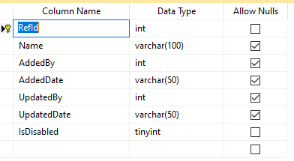

ERFO_MT_EquipmentRequirement

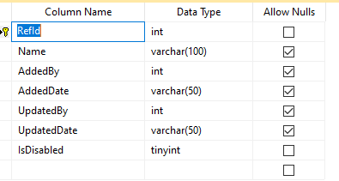

ERFO_MT_PurposeOfOperation

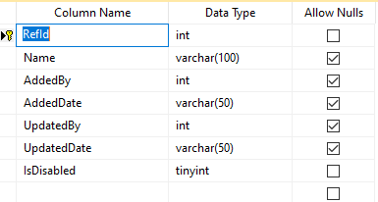

ERFO_MT_RecommendedContractor

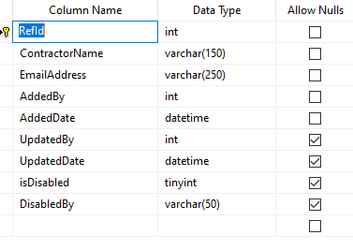

ERFO_TRANSACTION_Request

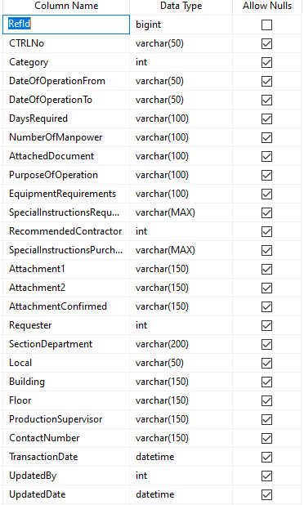

ERFO_TRANSACTION_SendReceived

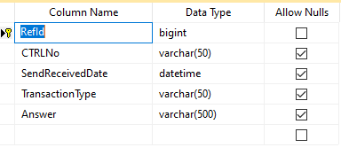

ERFO_TRANSACTION_Status

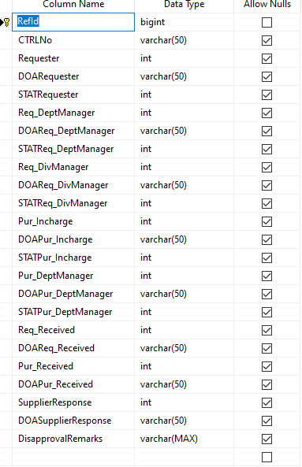

ERFO_TRANSACTION_SupplierAttachment

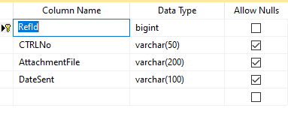

**SUPPLIER EVALUATION**

SE_MT_EvaluationCriteria_ForMaterial

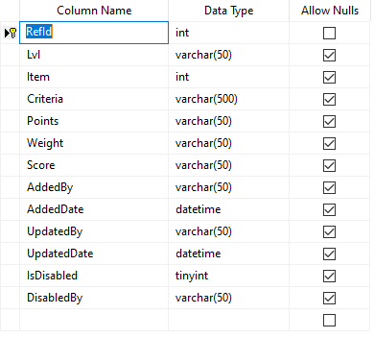

SE_MT_EvaluationCriteria_Maker

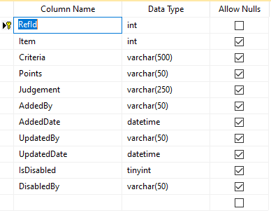

SE_MT_EvaluationCriteria_Trader

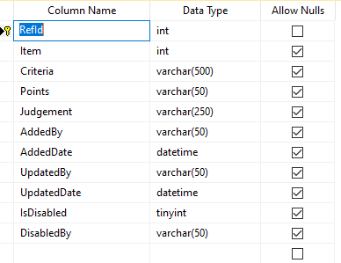

SE_MT_EvaluationItem

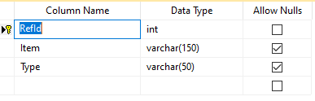

SE_MT_FiscalYear

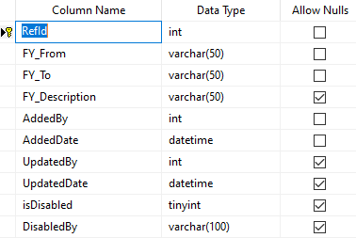

SE_TRANSACTION_RequestDetails

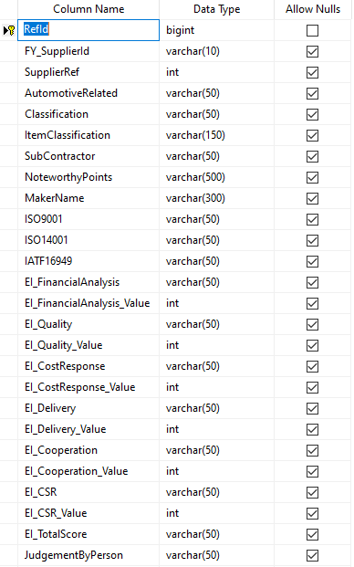

SE_TRANSACTION_RequestHead

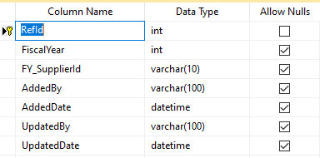

SE_TRANSACTION_Score

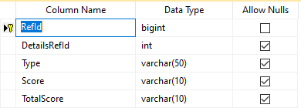

SE_TRANSACTION_SendReceived

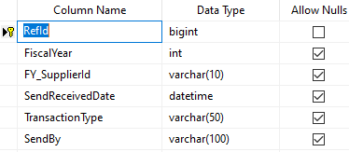

SE_TRANSACTION_StatusEvaluationTable

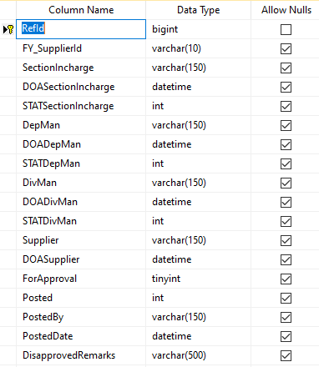

SE_TRANSACTION_StatusRevaluationSheet

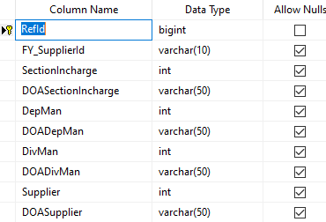

**SRF PULLOUT**

SRF_MT_PullOutContainerTubes

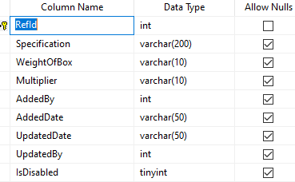

SRF_MT_PullOutICTrays

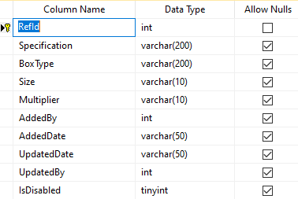

SRF_MT_PullOutOthers

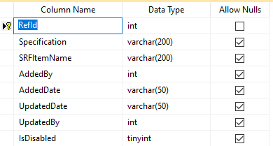

SRF_TRANSACTION_PO_Details

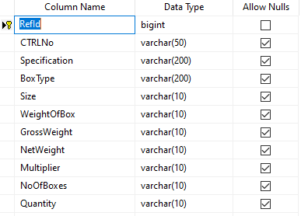

SRF_TRANSACTION_PO_Head

